**Open Configurable Networks Lab2**

**Todo:** In this lab, we will employ fully digital communication system, exploring common forms on digital carrier modulation, ideal receiver structure, bit-error performance and understand the impact of noise and interference on the performance of digital communication system. In the later part, we all also explore carrier synchronization and symbol synchronization (timing recovery) in an example scenario to explain the need for and importance of these blocks in a modern digital system [and in turn, how SDR could play a role in such systems]. Theoretical backgrounds, if any, will be covered in the appendix.

1. **Digital carrier modulated waveforms**

**Question 2.1: Take a screen capture of the Spectrum Analyzer window showing the broadcast signal that is observed.**

As we can see from the figure below, we can observe three main signals, and their frequencies are around 10kHz, 50kHz and 90kHz.

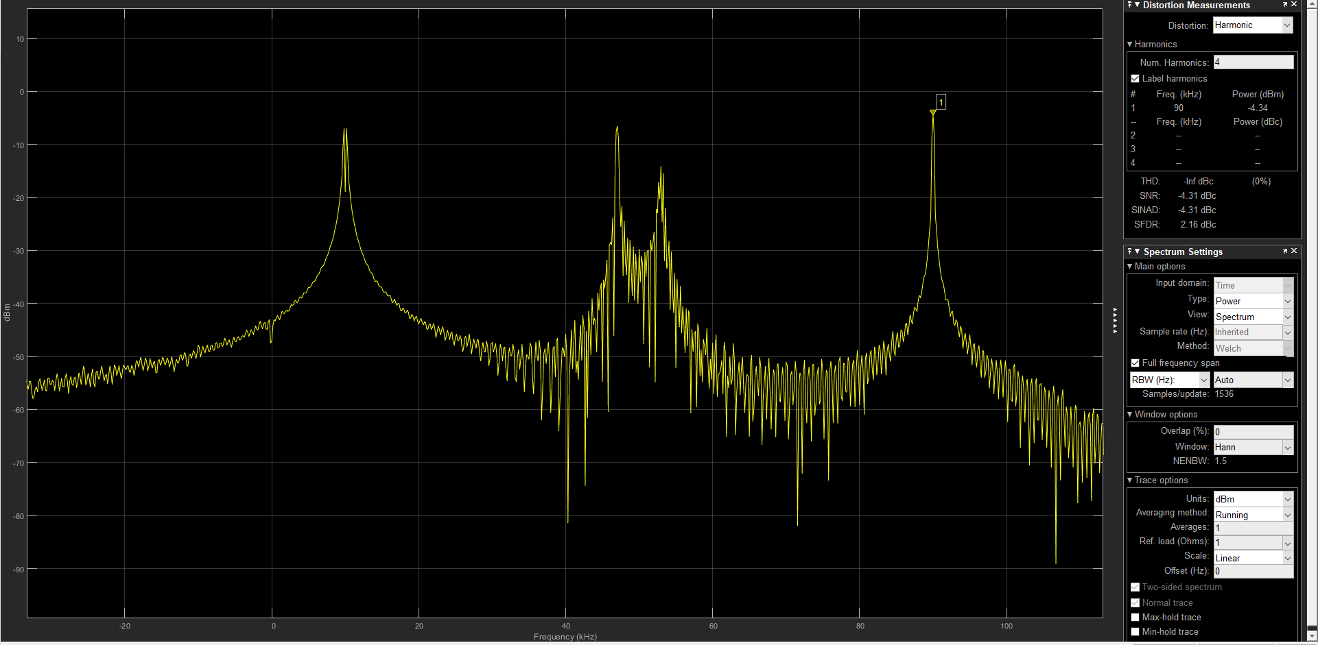

1. Spectrum of the signal

**Question 2.2: Identify each of the digital communication signals within your received signal. From the screen captures of Spectrum Analyzer and Time Scope, can you characterize each signal? Also, from the time/frequency plots, can you determine the bit rate for each signal and indicate how you determined them. Compare, and contrast the salient features seen in the plots.**

There are three digital communication signals which frequencies are around 10kHz, 50kHz and 90kHz, we employ three filters and observe these signals.

* + 1. **Signal 10kHz:**

The filter is designed as below,

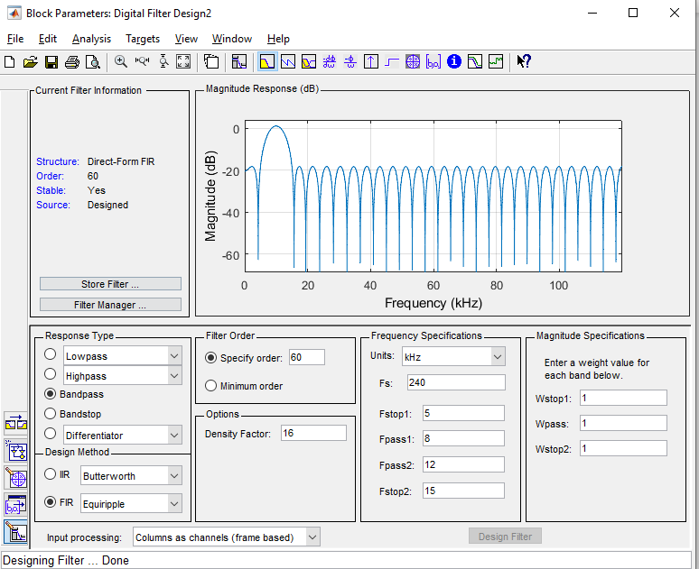

1. Filter parameters(10kHz)

The spectrum in frequency domain is shown as below.

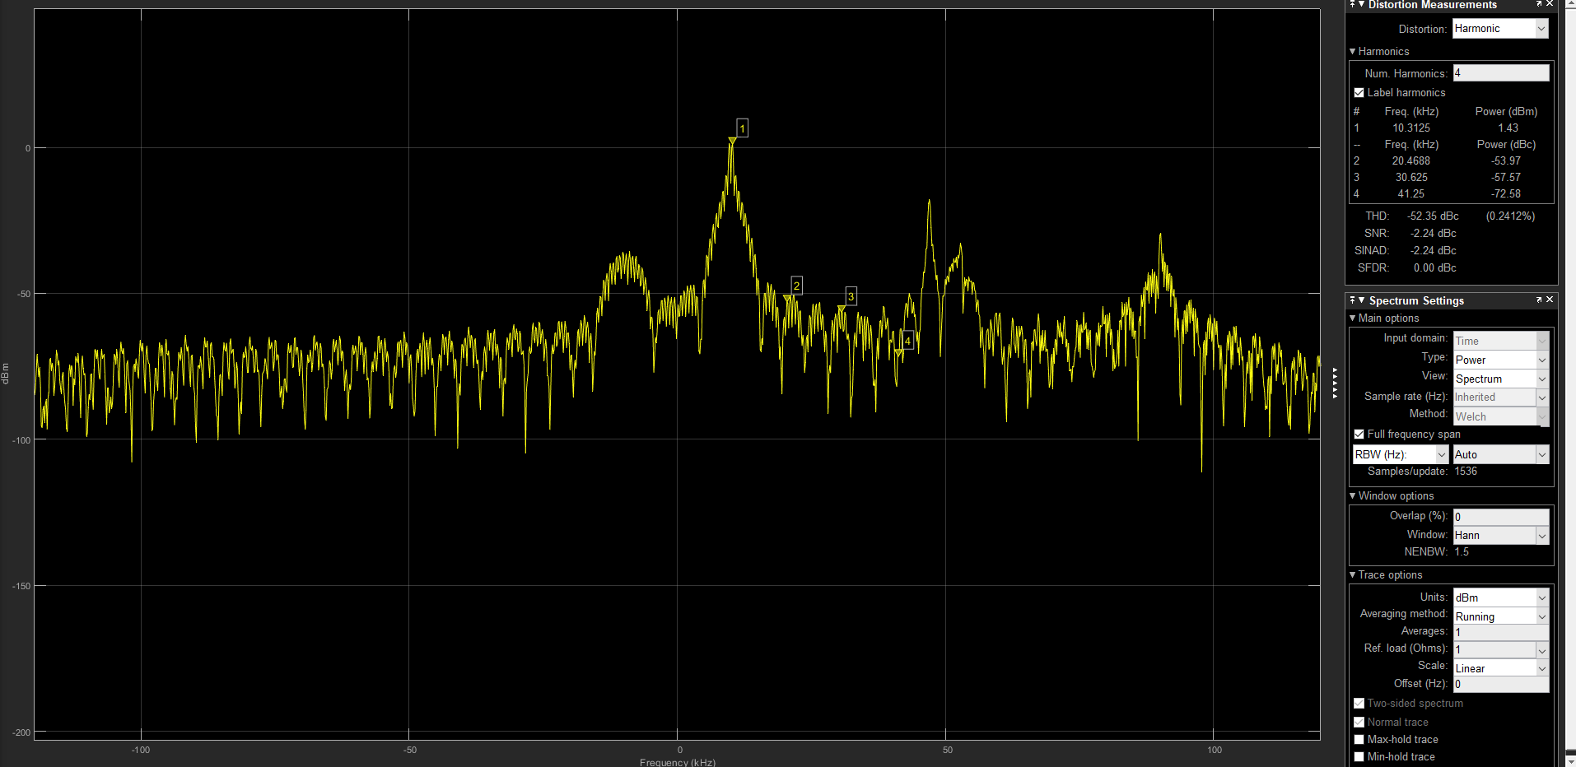

1. Spectrum after filter(10kHz)

The waveform in time domain is shown as below, and we can see that the carrier frequency of the signal is 10kHz, and the minimum unit in the time domain indicates that the bit rate of the signal is 600Hz and the modulation scheme we are using is BPSK, so the sample rate of the signal is equals to the bit rate as 600bps.

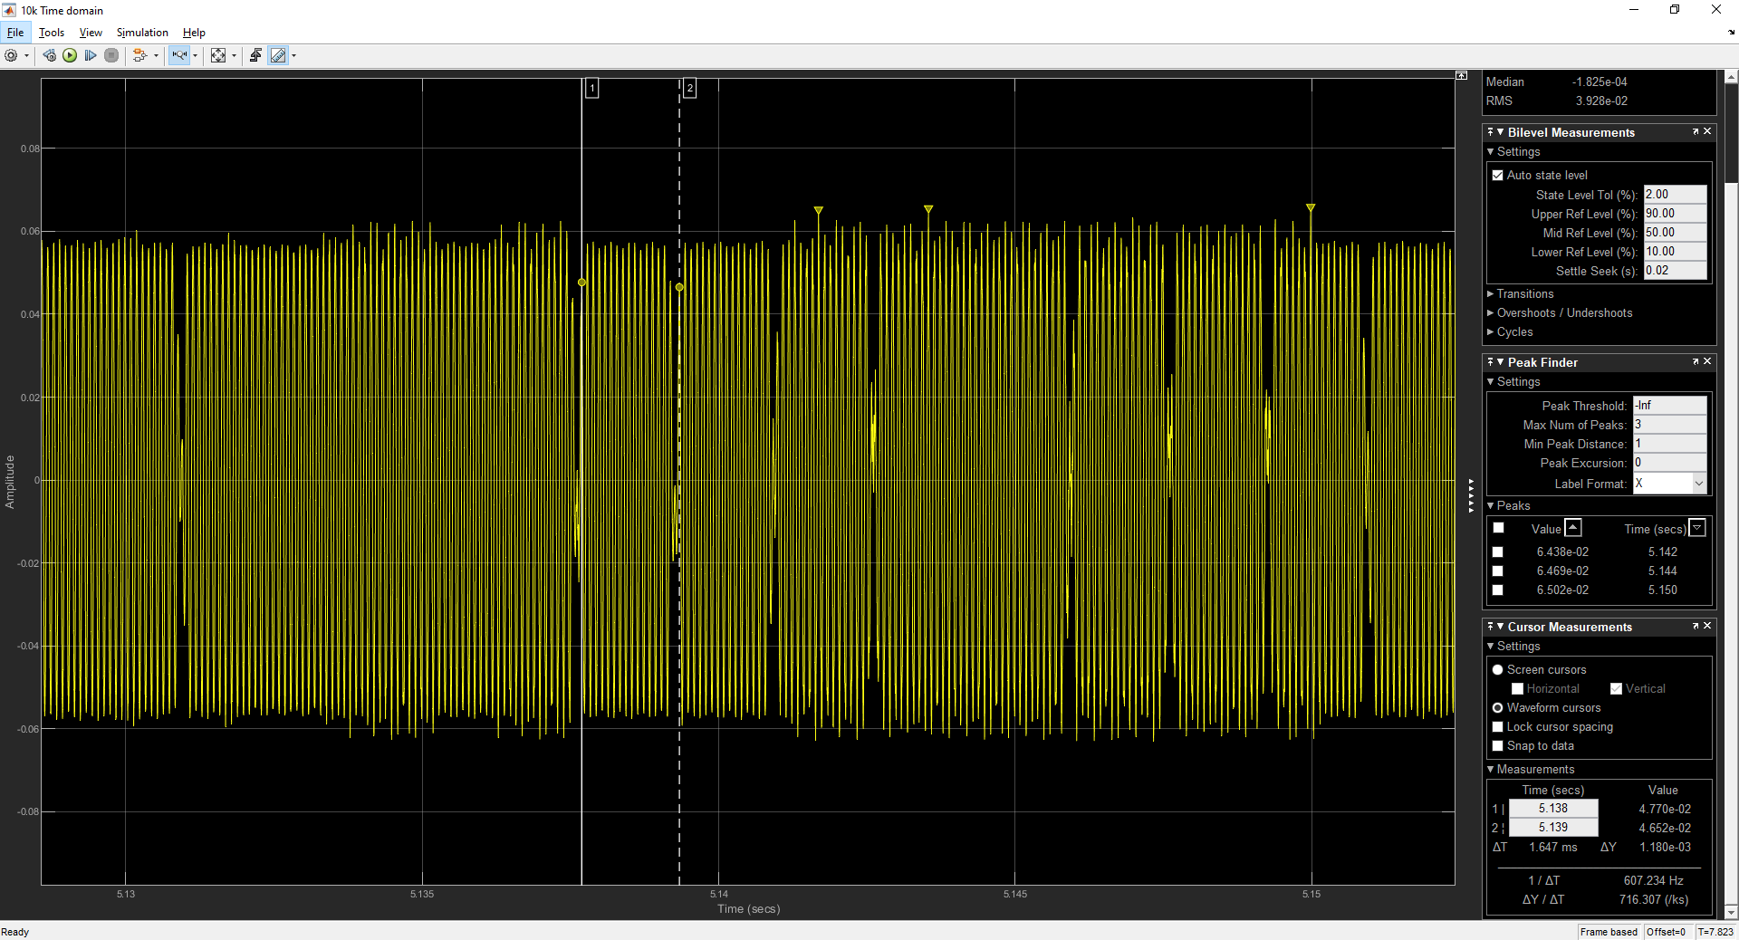

1. Waveform in time domain(10kHz)

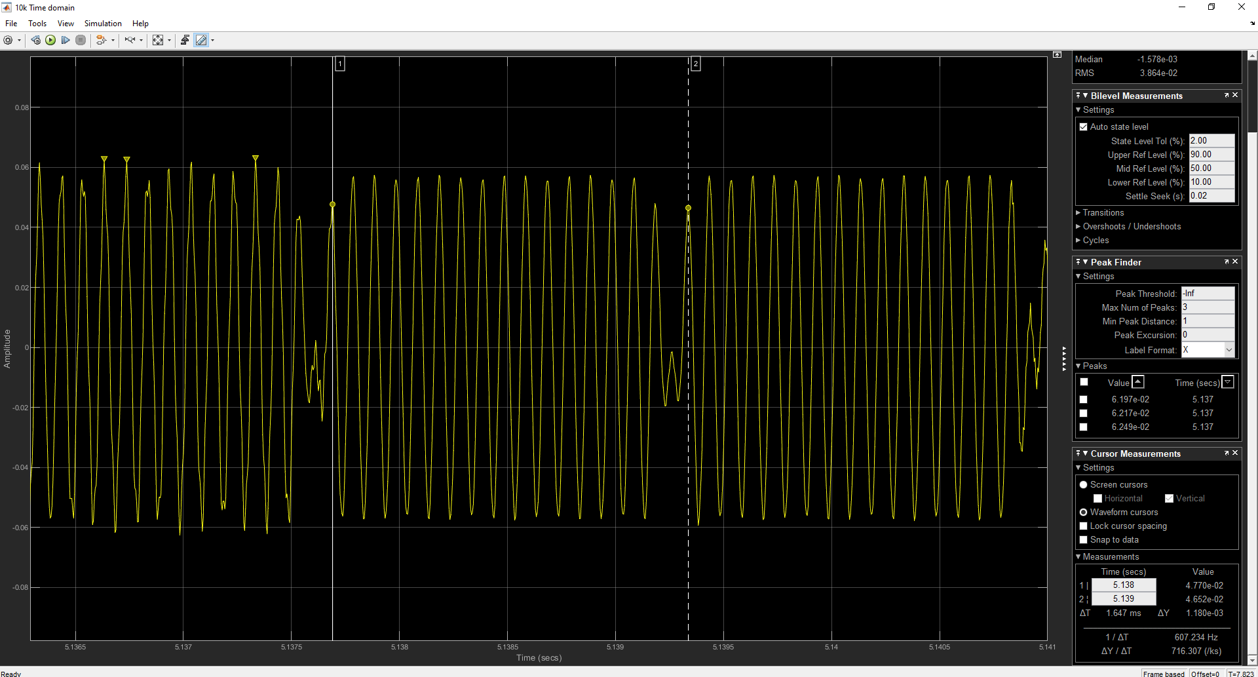

1. Signal with BPSK
   * 1. **Signal 50kHz:**

The filter is designed as below,

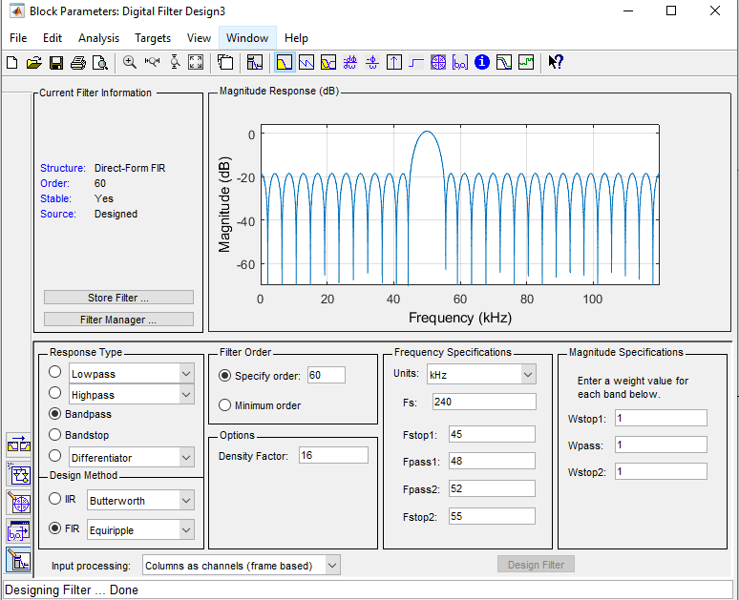

1. Filter parameters(50kHz)

The spectrum in frequency domain is shown as below.

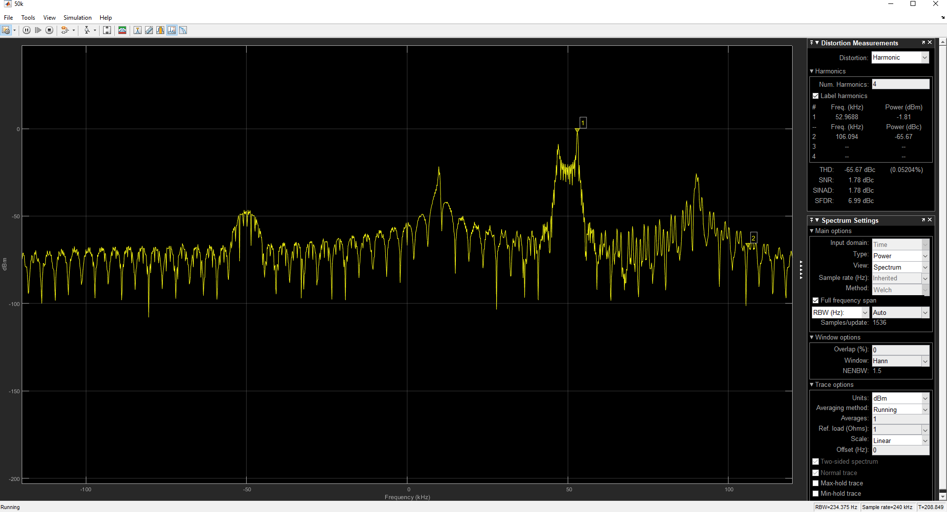

1. Spectrum after filter(50kHz)

The waveform in time domain is shown as below, and we can see that the carrier frequency of the signal is 50kHz, and the minimum unit in the time domain indicates that the bit rate of the signal is 770Hz and the modulation scheme we are using is BFSK, so the sample rate of the signal is equals to the bit rate as 770bps.

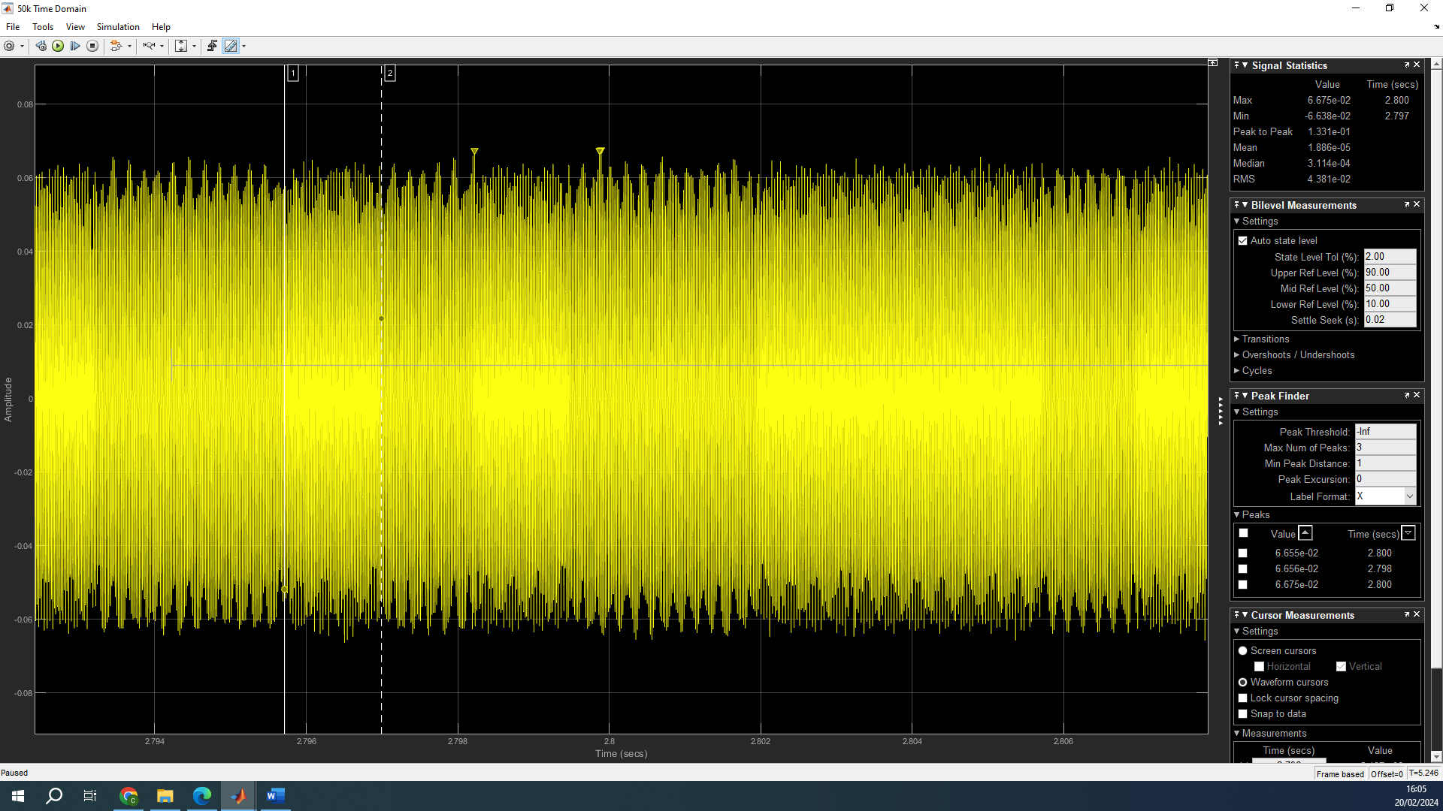

1. Waveform in time domain(50kHz)

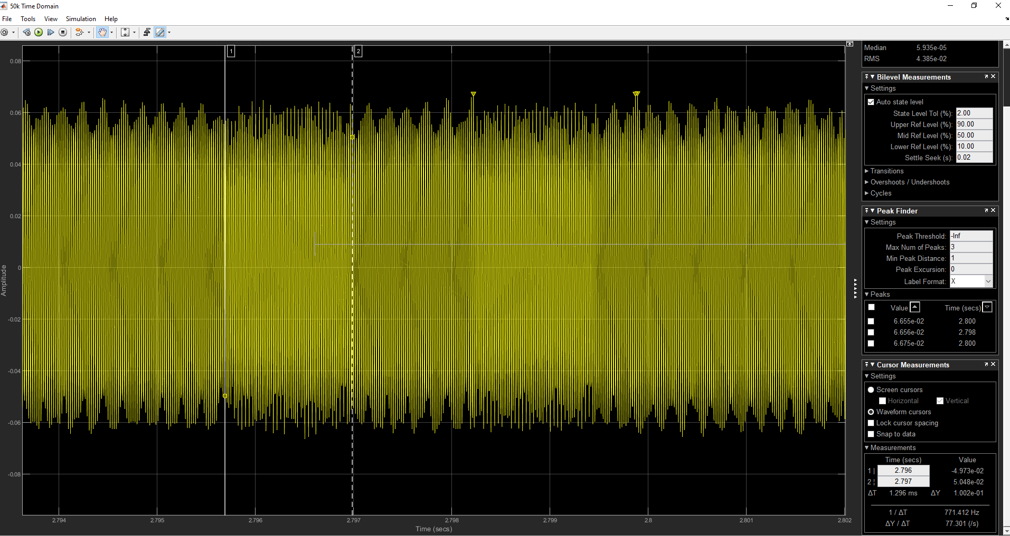

1. Signal with BFSK
   * 1. **Signal 90kHz:**

The filter is designed as below,

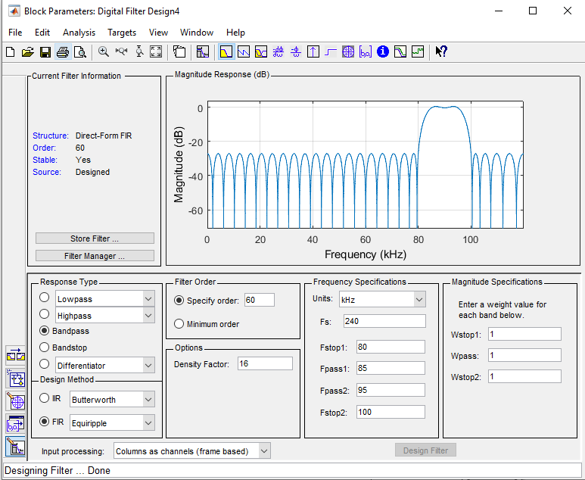

1. Filter parameters(90kHz)

The spectrum in frequency domain is shown as below.

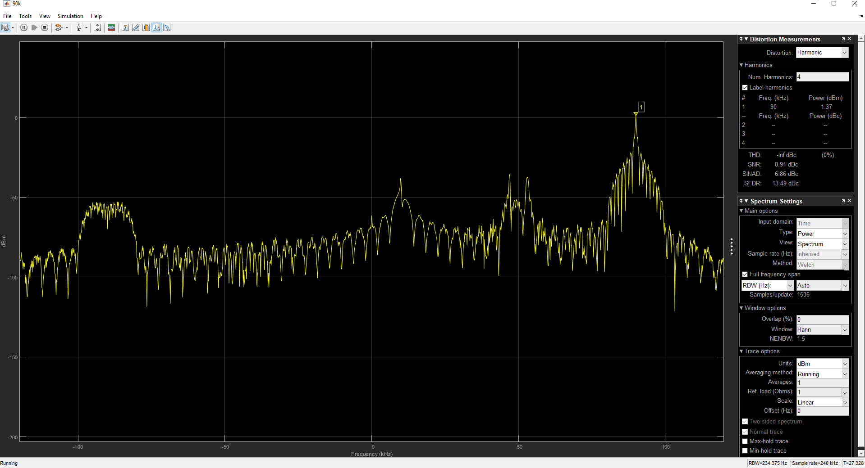

1. Spectrum after filter(90kHz)

The waveform in time domain is shown as below, and we can see that the carrier frequency of the signal is 90kHz, and the minimum unit in the time domain indicates that the bit rate of the signal is 1kHz and the modulation scheme we are using is BASK, so the sample rate of the signal is equals to the bit rate as 1kbps.

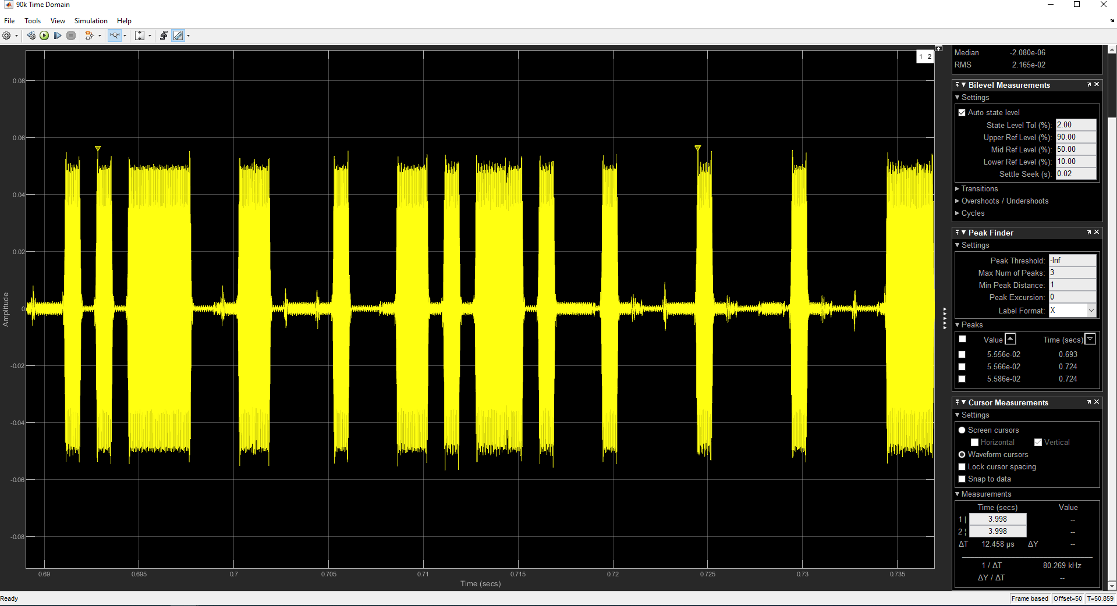

1. Waveform in time domain(90kHz)

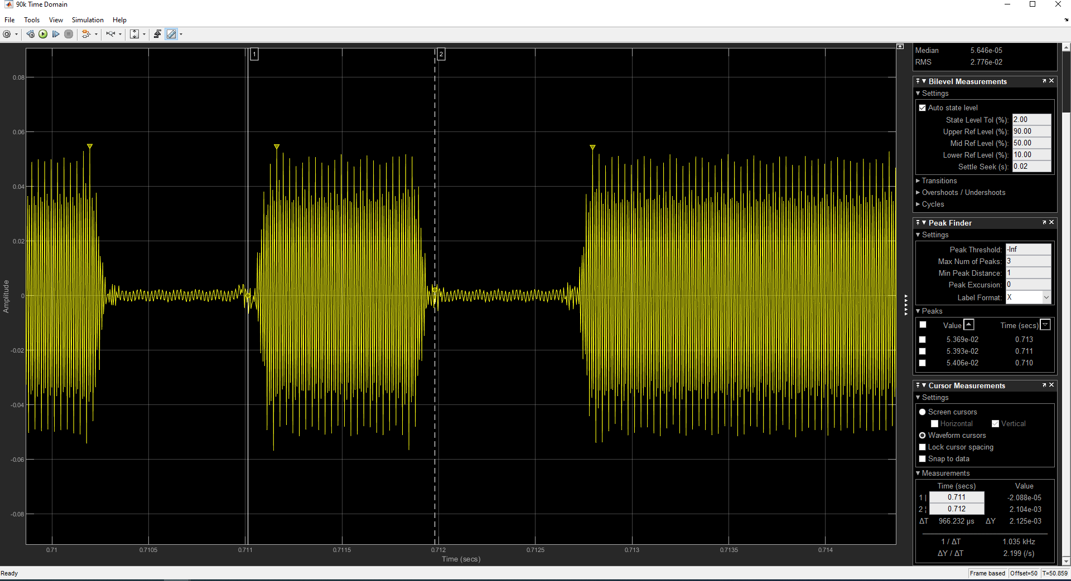

1. Signal with BASK

**Question 2.3: One of communication signals in your received wide-band signal use binary Amplitude Shift Keying (ASK), which is essentially a binarized amplitude modulated (DSBAM) waveform. Using your non-coherent DSBAM receiver from Lab 1, recover the actual baseband message. Add a screen capture of the Simulink model and a Time-Scope window showing the message waveform in your submission.**

The signal whose carrier frequency is around 90kHz employs the ASK which is essentially a DSBAM waveform. Utilize the model in Lab1, we can analysis the signal and the structure and the waveform is shown as below.

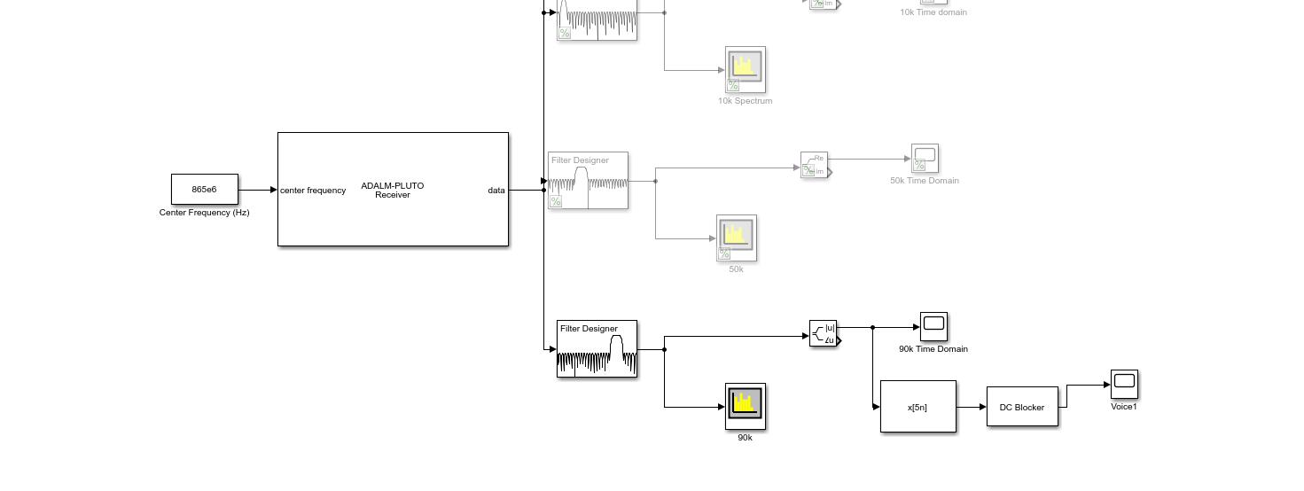

1. Block Design Structure

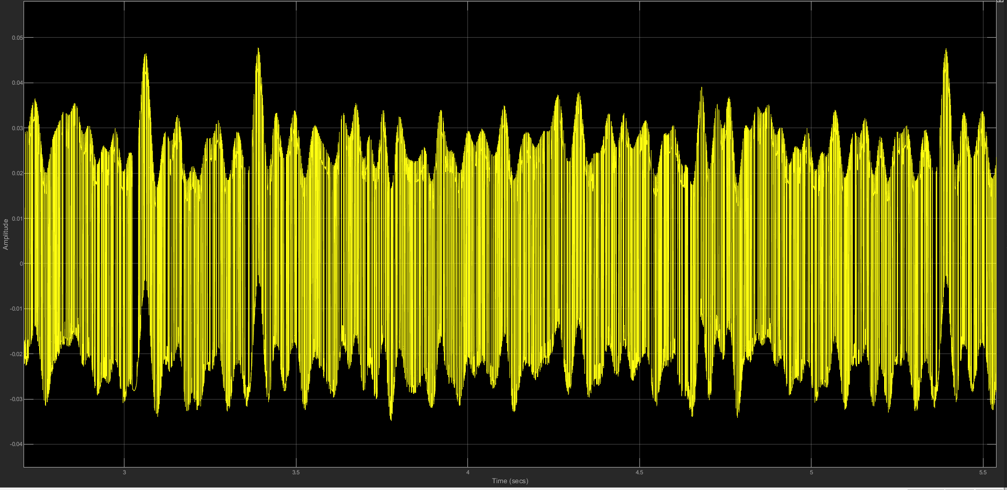

1. Recovered signal
2. **Bit Error Rate Simulation**

**Question 3.1: With a Time Scope, block added, use it to display the output of the Ideal Rectangular Pulse Filter block. Can you determine the average signal power?**

We can observe the peak value of the TX signal in real and image part are 0.5 and 0.866, if we assume these symbols are equal possibility distribution, we can calculate that the average signal power as below.

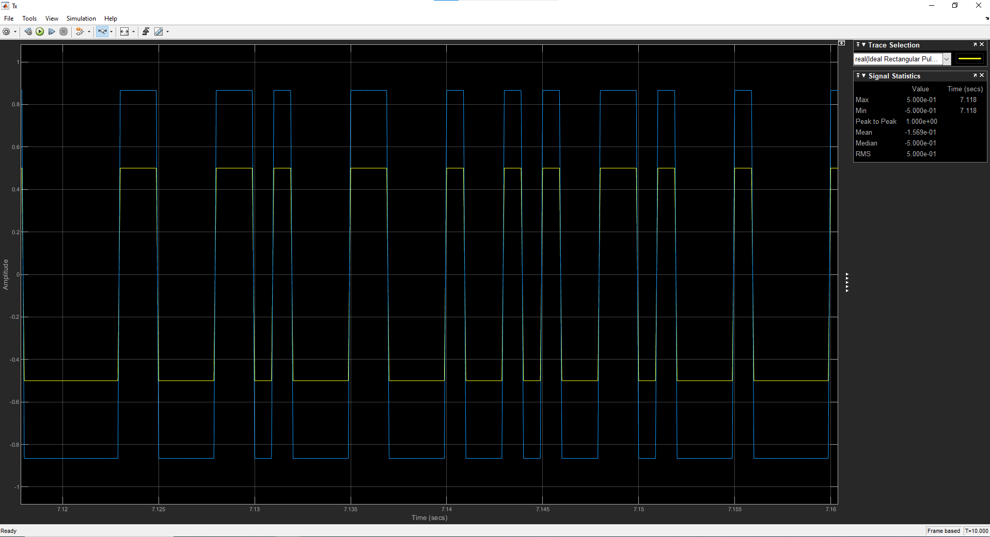

1. Output of the pulse shaping filter

**Question 3.2: Using a Time Scope block, observe the input to the AWGN Channel block, the output of the AWGN Channel block, and the output of the Gain block. In the AWGN Channel block, set the Input signal power to the value you calculated in the previous problem and Eb/N0 to 12dB. Set the remaining parameters based on your understanding of the simulation. Run the simulation and take a screen capture of the Time Scope block. Explain and interpret the plots.**

The input of the AWGN Channel block is as same as the picture in the previous section.

The output of the AWGN Chanel is shown as below, we can see that the signal we transmit is distorted by the AWGN channel.

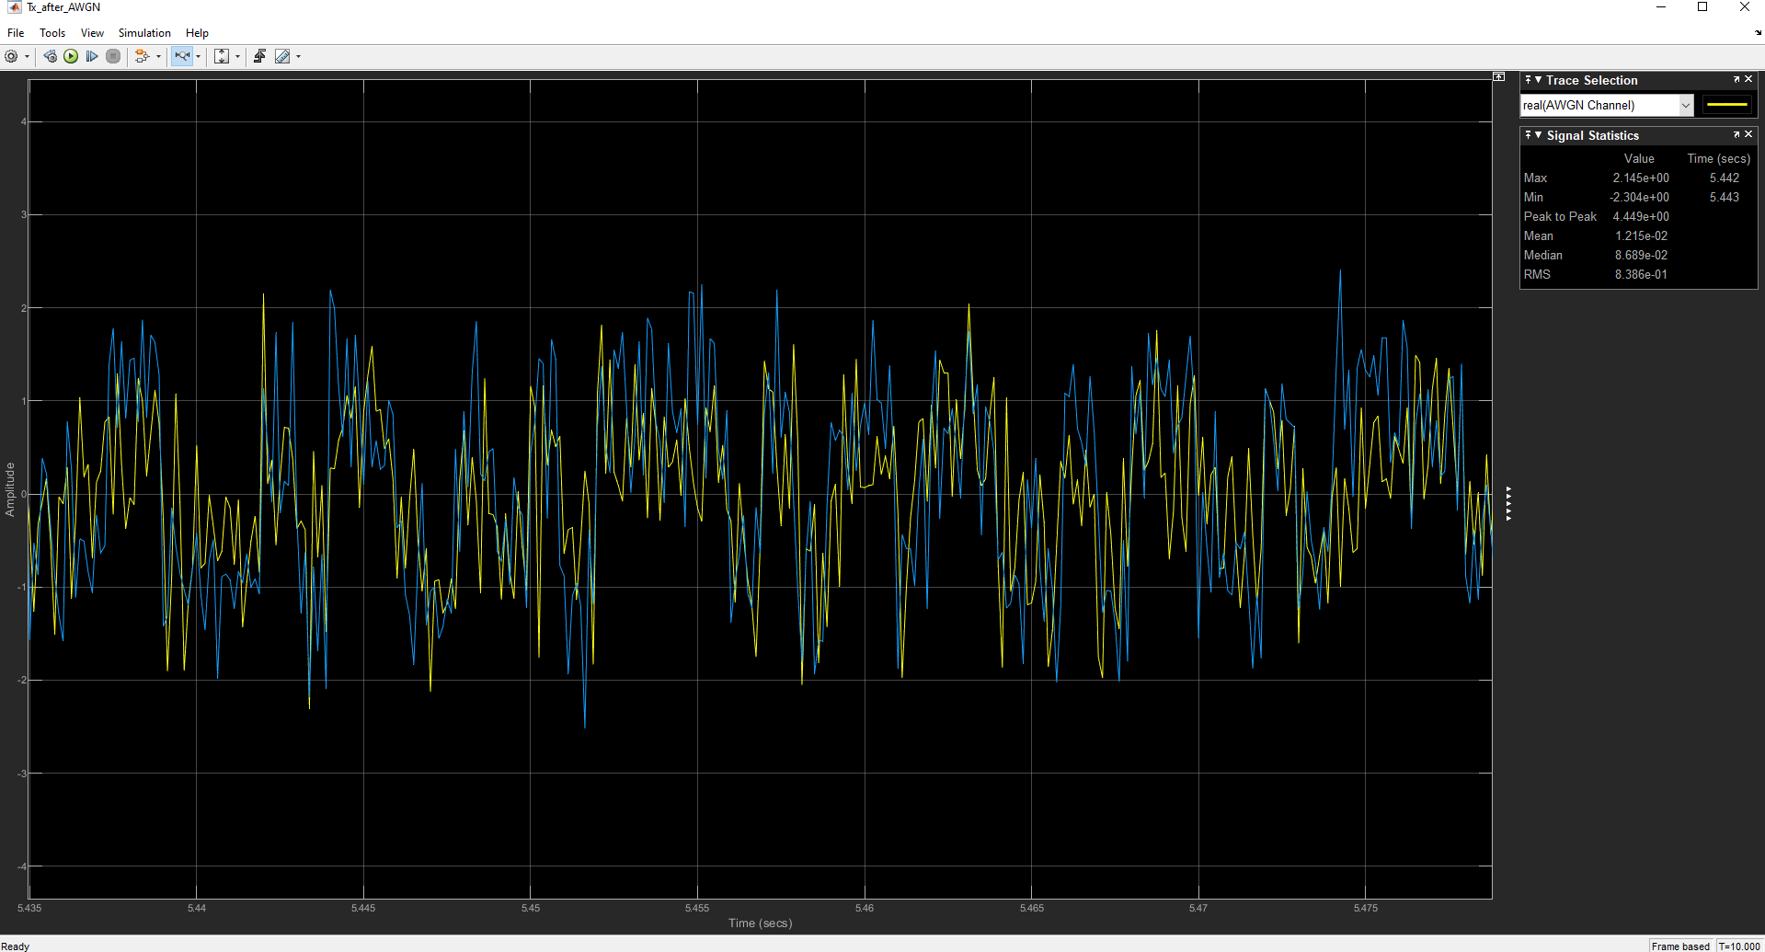

1. Signal after AWGN channel (Eb/N0 = 10dB)

The output of the gain model is shown as below, we can see that after the Integrate and dump operation, we can extract the original signal and then adjust its amplitude with the gain model.

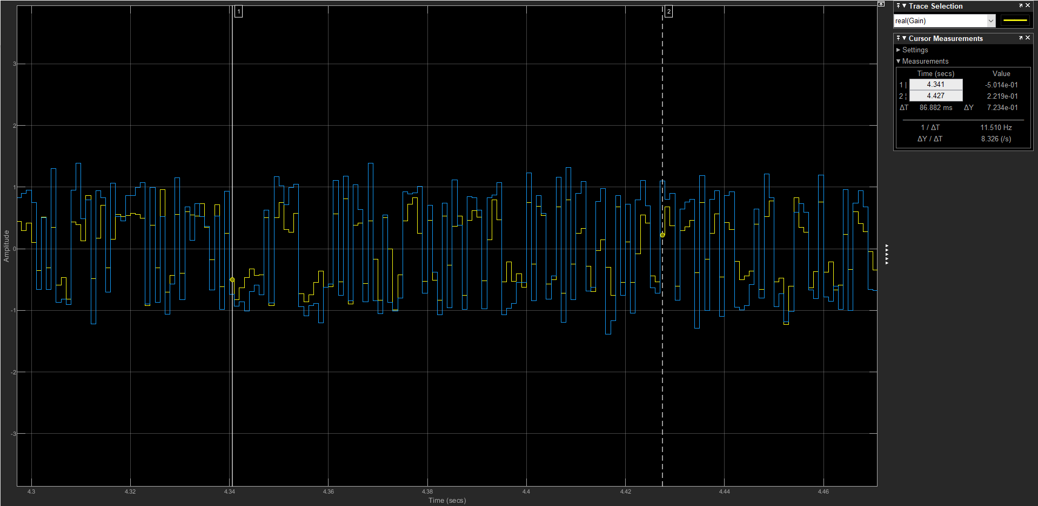

1. Signal after Integrate and dump and gain(Eb/N0 = 10dB)

The parameters of the AWGN channel are shown as below.

The meaning of these parameters:

**Initial Seed:** Because AWGN channel will generate noise by using random value, for the computer, it can only generate fake random value, to make the random value different, we nee a random value initial seed, but this does not matter, so we set it as default value 67.

**Mode:** The method to scale the noise.

**Eb/N0:** The ratio of the information energy vs noise, with a higher value, we will have less noise.

**Number of bits per symbol:** As we use BPSK modulation scheme here, this should be 1.

**Input signal power:** As we calculated before, this should be 1 Watt.

**Symbol period:** Follow the symbol rate, AKA bit rate of the input signal.

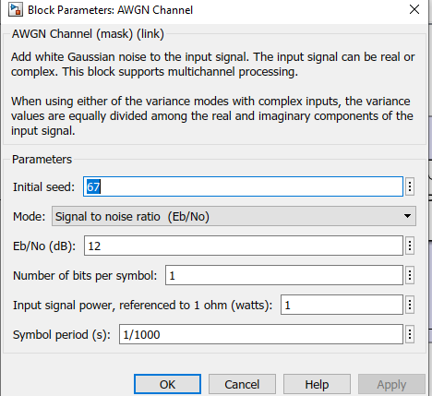

1. Parameters of the AWGN channel

Changing the input signal power to 1 watt and set Eb/N0 from 10 dB to 12 dB, we can observe the waveform as below. We can see that with the rate of Eb/N0 increasing, this means that there will be more energy of the signal and less energy for the noise, so the distortion will be less.

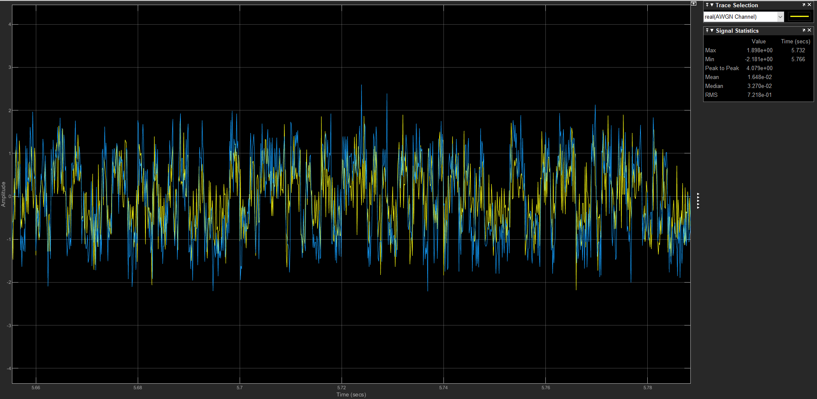

1. Signal after AWGN channel (Eb/N0 = 12dB)

**Question 3.3: Add Eye Diagram and Constellation Diagram blocks to the signal at the input of the BPSK Demodulator Baseband block. Set the AWGN Channel block for Eb/N0 of 12 db. Run the simulation, and take screen captures of the eye diagram and signal constellation. Repeat Eb/N0 for of 6dB. Comment on the observations and how the plots change as a function of Eb/N0.**

The eye diagram and constellation is shown as below when Eb/N0 is 12db.

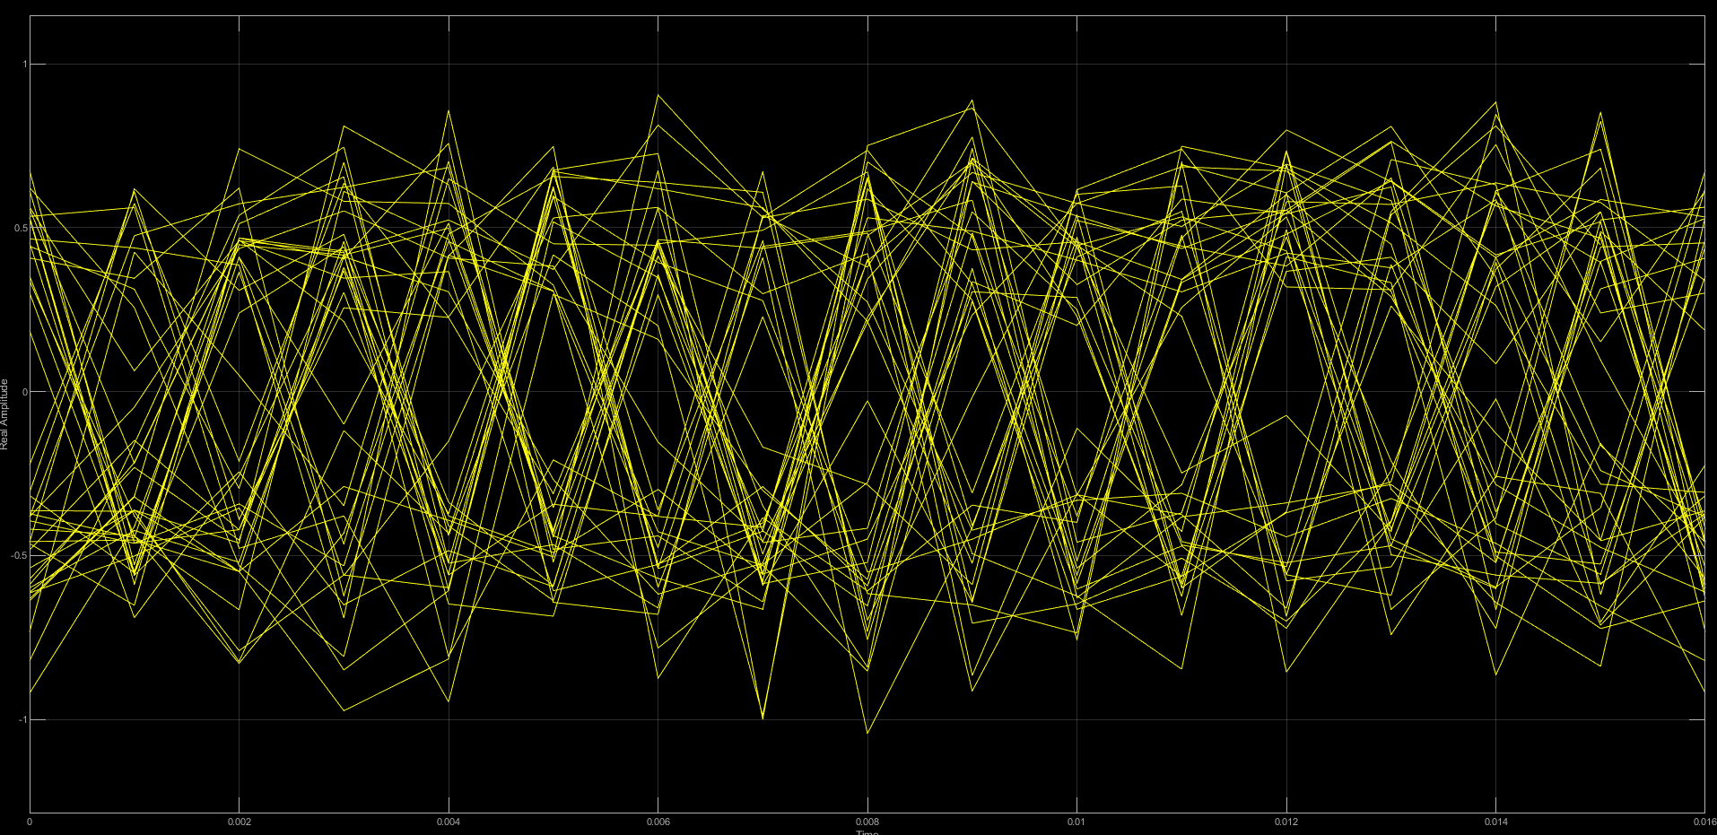

1. Eye diagram (Eb/N0 = 12dB)

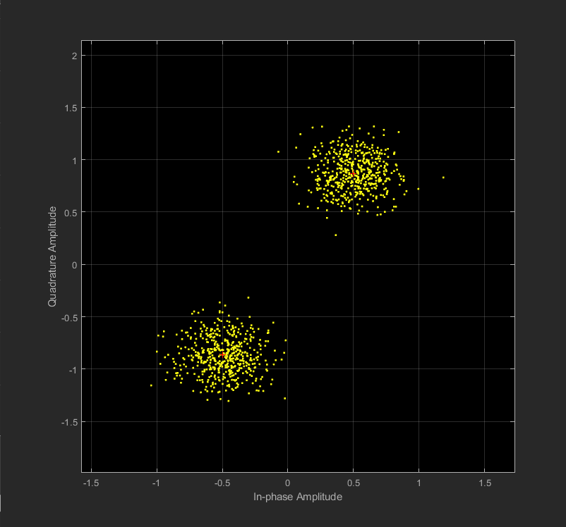

1. Constellation map (Eb/N0 = 12dB)

The eye diagram and constellation are shown as below when Eb/N0 is 6db.

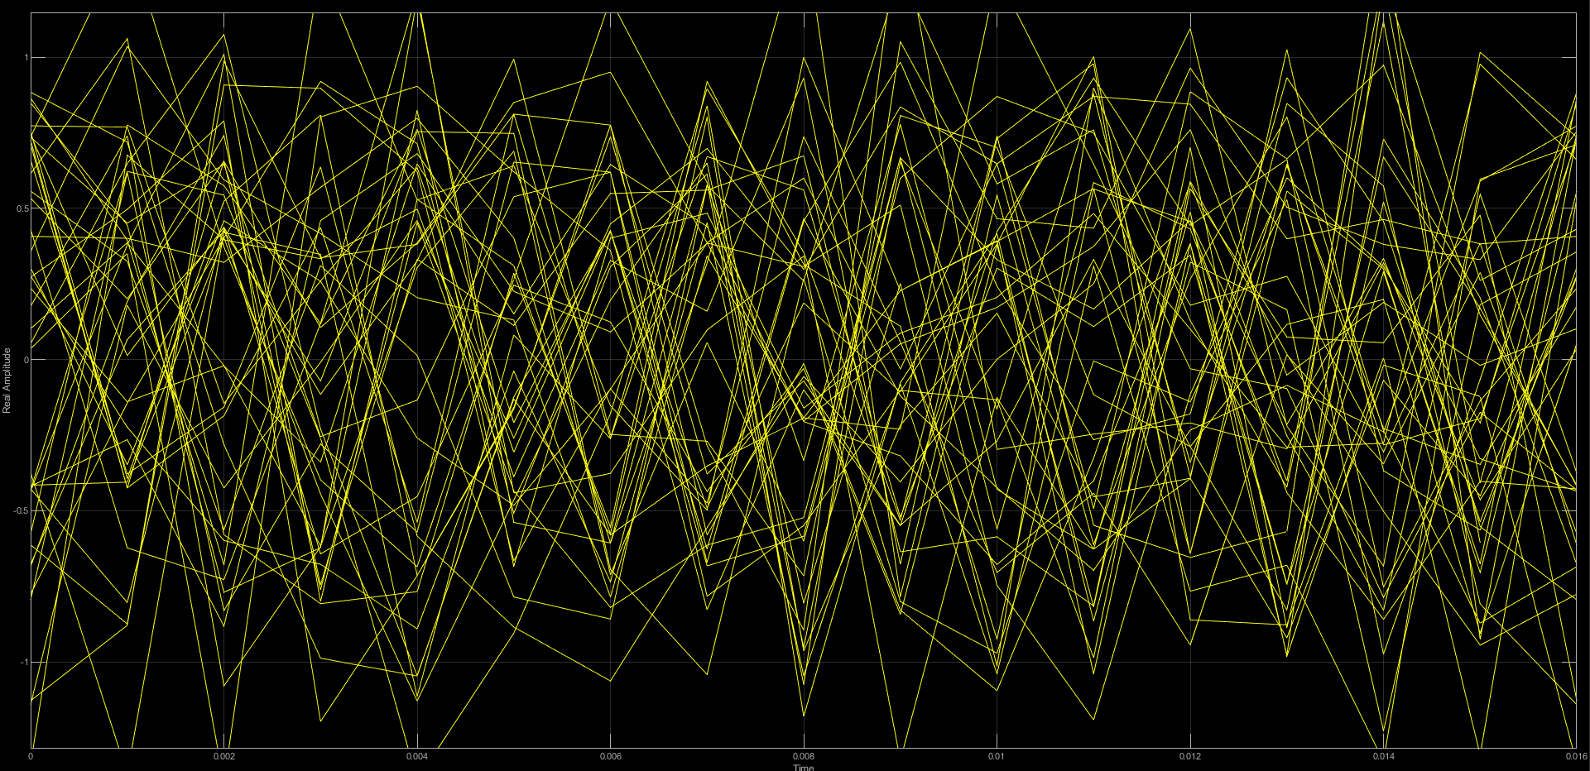

1. Eye diagram (Eb/N0 = 6dB)

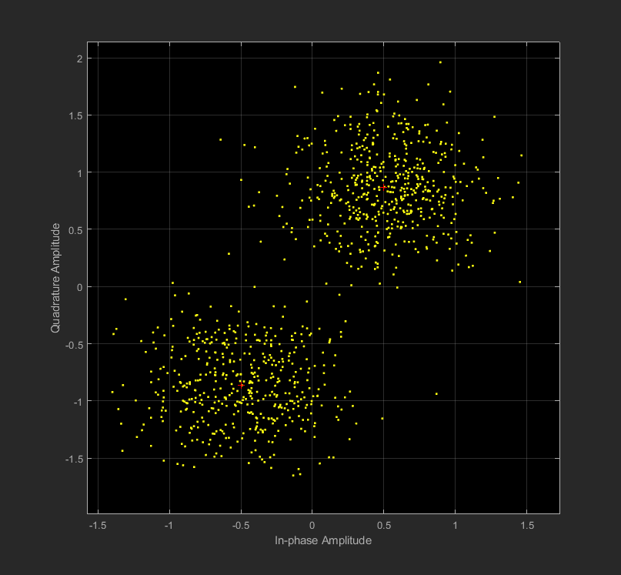

1. Constellation map (Eb/N0 = 6dB)

Let us look back to the definition of the eye diagram and the constellation. In the eye diagram, wider the eyes are open, it indicates that less distortion. In the constellation, longer distance of the signal point to the ideal position indicates how the signal was distorted in phase and amplitude.

As we decrease the Eb/N0 from 12dB to 6 dB, the noise is increasing, as we clarified above, the eye will close and the points in the constellation will be more discrete which indicates the signal was worse distorted.

**Question 3.4: You will now use the model to simulate the system performance over a range of Eb/N0 values.**

**• Run the simulation for Eb/N0 values of 0dB to 12dB in 4dB steps.**

**• Set the simulation time to ensure the results are meaningful. This is especially important when very few bit errors are expected.**

**• Observe and record the error rate for each run.**

**• Plot bit error rate vs Eb/N0 and compare to the theoretical prediction. What are your thoughts on the results?**

For the Eb/N0 values vary from 0dB to 12dB in 4dB steps. We can observe the bit error rate as below.

1. Eb/N0(dB) vs Bit Error Rate

|  |  |  |  |  |
| --- | --- | --- | --- | --- |
| Eb/N0(dB) | 0 | 4 | 8 | 12 |
| Bit Error Rate | 0.078 | 0.013 | 0.00018 | 0 |

Plot this data and compare with the ideal result, we can have the figure below. We can see that the bit error rate we observed is almost equals to the Bit Error Rate Cure predicted value. And we can believe that with more data points, they will curve better.

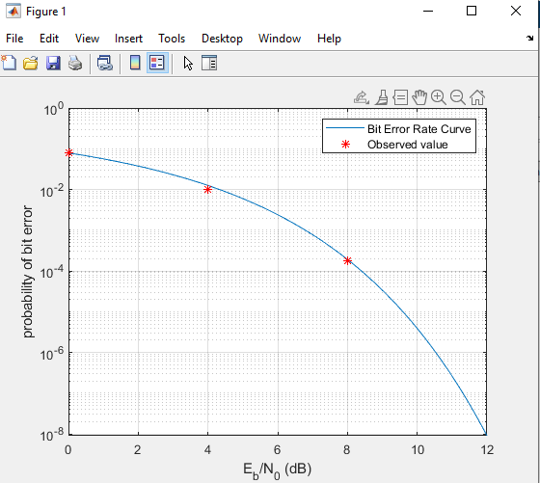

1. Bit Error Rate vs Eb/N0(dB)